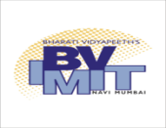
Bharati Vidyapeeth’s
Institute of Management & Information Technology
Navi Mumbai

Ph.D. Programme (Technology) in Computer Application

RESEARCH TOPIC/TITLE PROPOSAL

Date:
Name of the Research Scholar :
Date of Admission :
Name of the Supervisor :
Title of Research Proposed :

Expert Comments:

- Breadth of literature survey: done / more required / to be started

- Gap analysis: issues identified –

- Is the Problem Scope sufficient for Ph.D. :

- Is the candidate line of thinking leads towards solution:

- Is the proposed title/field of research too narrow / broad:

- Final Remarks:
(i) Topic approved:

(ii) Recommended for further revision & presentation:

(iii) Topic not approved:

External Expert: Internal Expert:

Research Supervisor: R&D Coordinator:

